RIPHAH INTERNATIONAL UNIVERSITY, ISLAMABAD



NAME: Saqba Yasmin
Sap id: 63476
Program: BSCS-3
Submitted To: Mam Rehana Sanam
COAL Lab
Lab Task

TASK 1:

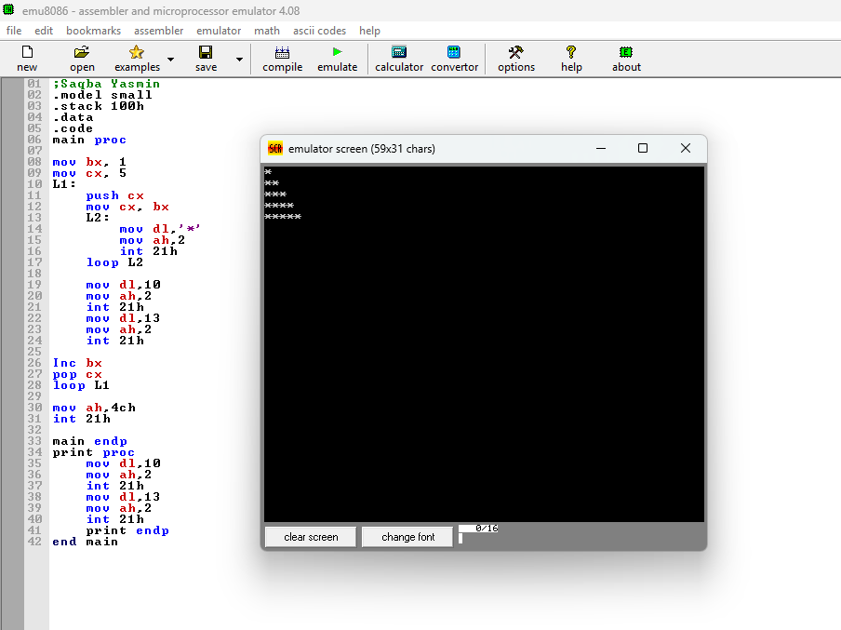

TASK 2:

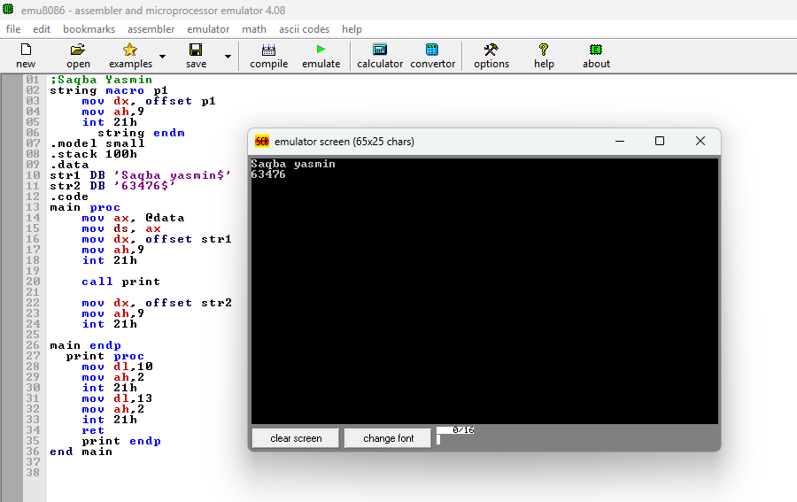

TASK 3:

